**C3- S1-HANDOUT**

# Getting started with the Internet

The Internet is a global network of billions of computers and other electronic devices. With the Internet, it's possible to access almost any information, communicate with anyone else in the world, and much more. You can do all of this on your computer.

**Network** is the connection between two or more computers and can communicate with each other.

**History of Internet**

Internet was invented by:

**The Internet**

:

is the connection of millions of networks to allow people can

communicate and sharing informat

ion.

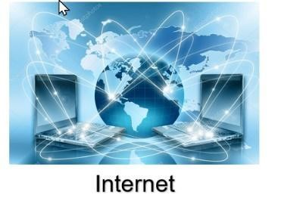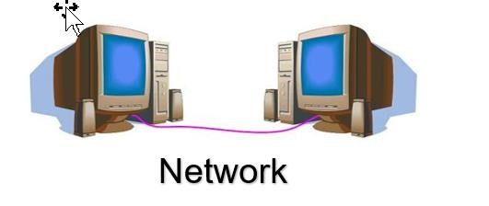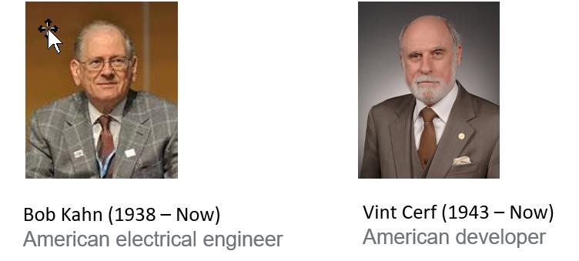

* The Internet as we know it today first started being developed in the late **1960s** in California in **the United States**.
* The **Internet** was first **invented** for military purposes, and then expanded to the purpose of communication among scientists.

# Connecting to the Internet

A device has to be connected to the Internet before you can access it. If you plan to use the Internet at home, you'll usually need to purchase an Internet connection from an **Internet Service Provider (ISP)**. Other devices usually connect through **Wi-Fi** or **cellular Internet** connections. Sometimes libraries, cafes, and schools offer free Wi-Fi for their patrons, customers, and students.

# Browsing the Web

Most information on the Internet is on **websites**. Once you are connected to the Internet, you can access websites using a kind of application called a **web browser**.

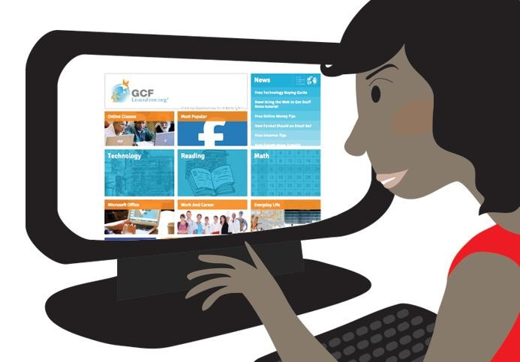**A** **website** is a collection of related text, images, and other resources. Websites can resemble other forms of media—like newspaper articles or television programs—or they can be interactive in a way that's unique to computers. The purpose of a website can be almost anything: a news platform, an advertisement, an online library, a forum for sharing images, or an educational site like us!

**A web browser** allows you to connect to and view websites. The web browser itself is not the Internet, but it displays pages on the Internet. Each website has a unique address. By typing this address into your web browser, you can connect to that website and your web browser will display it.

**A website address:** is a name that points to a location where a website is hosted over the internet. It is also known as the **URL** (uniform resource locator).

* The PNC website's address is: <http://www.passerellesnumeriques.org/>
* The “Our Partner" Page has URL:

<http://www.passerellesnumeriques.org/category/our-partners/>

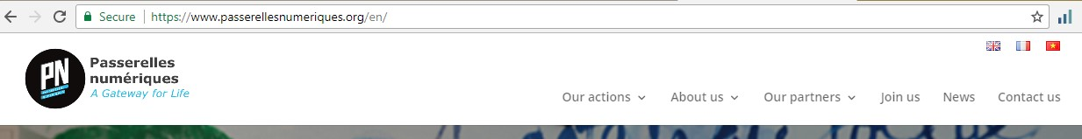

# Navigating websites

Websites often have **links** to other sites, also called **hyperlinks**. These are often parts of the text on the website. They are usually colored blue, and sometimes they are underlined or bold. If you click the text, your browser will load a different page. Web authors use hyperlinks to connect relevant pages. This web of links is one of the most unique features of the Internet, lending to the old name World Wide Web.

Each website has a unique address, called a **URL**. You'll notice that when you click a link, the URL changes as your browser loads a new page. If you type a URL in the address bar in your browser, your browser will load the page associated with that URL. It's like a street address, telling your browser where to go on the Internet.

When you're looking for specific information on the Internet, a **search engine** can help. A search engine is a specialized website that's designed to help you find other websites. If you type keywords or a phrase into a search engine, it will display a list of websites relevant to your search terms.

# Other things you can do on the Internet (World Wide Web)

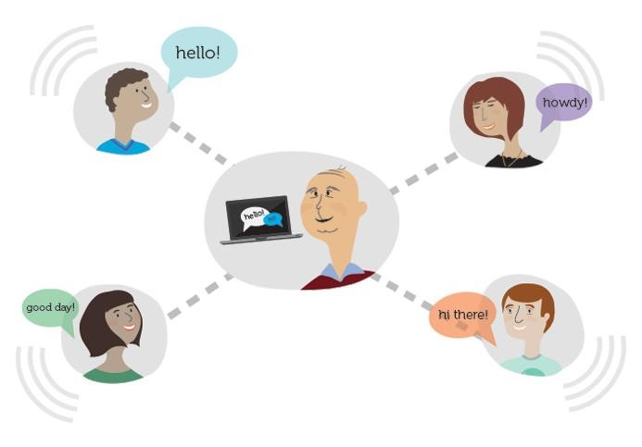One of the best features of the Internet is the ability to communicate almost instantly with anyone in the world. [**Email**](http://www.gcflearnfree.org/email101/1) is one of the oldest and most universal ways to communicate and share information on the Internet, and billions of people use it. [**Social media**](http://www.gcflearnfree.org/socialmedia) allows people to connect in a variety of ways and build communities online.

There are many other things you can do on the Internet too. There are thousands of ways to keep up with news or [**shop for anything**](http://www.gcflearnfree.org/using-the-web-to-get-stuff-done/online-shopping-advice) online. You can pay your bills, [**manage your bank accounts**,](http://www.gcflearnfree.org/online-money-tips/online-banking-101) meet new people, [**watch TV**,](http://www.gcflearnfree.org/using-the-web-to-get-stuff-done/streaming-video-services) or learn new skills. You can learn or do almost anything online.

# Understanding URLs

Every time you click a link on a website or type a web

address in your browser, it’s a URL. URL stands for Uniform Resource Locator. Think of it like a street address, with each portion of the URL as different parts of the address and each giving you different information.

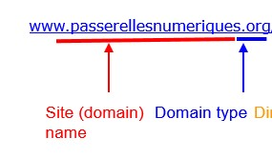

▪ **Prefix (http)** – an internet application protocol of your domain.

▪ **Subdomain (www)** – the third level domain of your website name (some sites use, some not).

▪ **Name (example)** – the second-level domain of the website, picked by the person registering the domain.

▪ **Extension (.com)** – the **top-level domain** can be picked for the variety of available choices. **Type of Domains**

Top Global Domain: Top country domain:

Com: (global) commercial .us - USA

Edu: US education .kh - Cambodia

Org: (global) organization .sg - Singapore

Mil: US military .fr - France

Gov: US government .vn - Vietnam

Net: (global) network provider .cn - China

**HTTPS:**



- **https** indicates a secure page. t means the site has added an extra level of security to protect your information from being seen or changed when it’s being sent. It does NOT mean the page is secure from other kinds of attack!

**Search Engine**

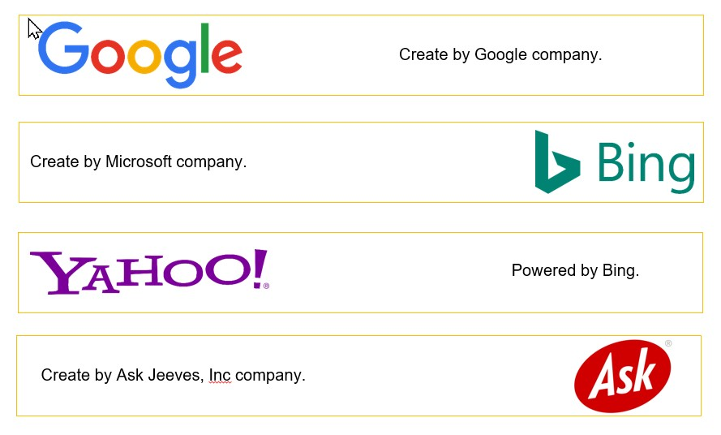

# C3- S1-QUESTIONS

**Q1 -** What is the Internet? Network?

**Q2 -** What Website?

**Q3 -** What is a Web Browser?

**Q4 -** What is a Web Address?